BALLYMAHON MUNICIPAL DISTRICT

Corporate Affairs,
Aras an Chontae,
LONGFOIRT.

16th February 2017.

To: Each Member of Ballymahon Municipal District.

Dear Member,

You are requested to attend Meeting of Ballymahon Municipal District to be held in
Ballymahon Community Library on Thursday, 23rd February 2017 as follows –

- 4.00 p.m. - Meeting of Municipal District to consider and approve
Schedule of Ballymahon Municipal District Works – report enclosed.

Yours sincerely,
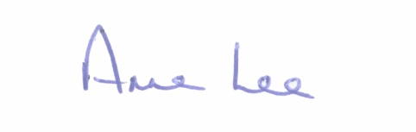

_______________
Anne Lee,
Meetings Administrator.

